

File Upload

Requirement Document

**Version 1.0**

|  |  |
| --- | --- |
| ***Corporate Office & Development Center*** | ***Offshore Development Center*** |
| *5 Concourse Parkway*  *Suite 3200, Atlanta, Georgia 30328*  *Tel 678.281.2014*  *Fax: 678.281.2019* | *Plot # 122 & 123, N.S.E.Z, Phase -2*  *NOIDA, UP 201 305*  *India*  *Tel: 91.11.91.2510483* |

|  |  |  |  |  |
| --- | --- | --- | --- | --- |
| **Author** | | | | |
| **Name** | **Role** | **Date of Preparation** | **Signature** | |
| Evelyn Yap | Project manager | 28-Jan-2015 | Evelyn | |
| **Reviewer(s)** | | | | |
| **Name** | **Role** | **Date of Review** | **Signature** | |
| Pravesh Kumar | Manager Projects |  |  | |
|  |  |  |  | |
| **Approver** | | | | |
| **Name** | **Role** | **Date of Approval** | **Signature** | |
| ChengChoon Yip | VP Ebix Exchange  Asia |  |  | |
| **Document Path** | **Version Number** | **Date of Release** | | |
|  | 1.00 | 26-Jan-2015 | | |
| **Revision History** | | | | |
| **Version Number** | **Date of Release** | **Section/ Page # Changed** | | **Details of Changes** |
| 1.00 | 28-Jan-2015 | All | | Document created |
| 1.3 | 13-Feb-2015 | Page 15 | | Clarification required section added |

|  |  |  |
| --- | --- | --- |
| **References** | | |
| **Document** | **Date Received** | **Author** |
|  |  |  |

Contents

1. Overview 4

**a.** 4

**b.** Module 4

**c.** Development Type 4

2. General Overview 5

2.1Under Upload Menu 5

2.2 Under TAC Claim File Upload Functions 5

2.3 Under SAP Claim File Upload Functions 5

2.4 Under Job Schedule Enquiry 6

3. Screen Layouts 6

3.1 TAC File Upload 6

4. Field Names & Functionality 6

5. TAC File Upload Status 7

6. Functionality 7

7. The Re-Upload Screen Layout 8

8. Claim Upload Screen Layout 9

9. TAC Claim Upload Process: 9

10. SAP Claim File Upload Process: 10

11. Claim File Upload Result (for both TAC & SAP) 10

12. Fields Mapping 11

13. Field Mapping Process 12

14. Field Mapping Output 12

17.1 Example Of Field Mapping Output 13

17.2 Field Mapping Validation 13

15. Updating Of Claims 13

16. Rule 14

17. Implementation 14

Current Implementation 14

Targeted Implementation 14

18. Change Required 14

# Overview

|  |  |  |  |
| --- | --- | --- | --- |
| ☒ | New | ☐ | Change Request |

* 1. Module

|  |  |  |  |  |  |
| --- | --- | --- | --- | --- | --- |
| ☐ | Diary | ☐ | System Admin Module | ☐ | Claim Registration |
| ☐ | Claim Payment | ☐ | Claim Recovery | ☐ | Claim Enquiry |
| ☒ | Upload | ☐ | Reports |  |  |

* 1. Development Type

|  |  |  |  |  |  |
| --- | --- | --- | --- | --- | --- |
| ☒ | Functionality | ☒ | Integration | ☐ | Rule |
| ☐ | Report | ☒ | Field | ☒ | Screen |

# General Overview

### 2.1Under Upload Menu

* File Upload & Convert Status – To convert 3 x TAC CSV Files into 1 TAC Claim File Upload and Display the Converting Results (with the option to download a Report File that shows which are the Failed Records and to re-upload those failed records & re-process it until all records have been processed)
* Claim Upload & Convert Status – User needs to select which organization to process file upload. For Bus / Train –System will show TAC Claim File Upload Functions. Other organizations will show SAP Claim File Upload Functions. Also to display process results and the

### 2.2 Under TAC Claim File Upload Functions

* User is to upload two compulsory files – TAC Standard Codes and TAC Claim File Upload. Under Standard Code CSV File, System will filter out those marked as 13 (Operating Hours), 21 (Final Finding) and 22 (Duty IO) in Column A.
* Records for Operating Hours and Duty IO will be stored in the backend and be processed along with the TAC Claim File Upload. Processing will involve converting the Number Codes in the TAC Claim Upload File appearing under Operating Hours and Duty IO into Description.
* For example, Column U under TAC_IP.csv is the Operating Hours and one of the value is 8 and under TAC_Standard_Codes, System will look for 8 under Column B and replace the value of 8 in the TAC_IP.csv into “WORKED 3 HRS 30 MINS” and put that description into the Claim Registration Section > Accident > Initial Findings > Operating Hours Field. Therefore the listing of this dropdown field needs to change to cater to the Standard Code.
* Under the Display Results, both the TAC Standard Codes and the TAC Claim File Upload Files need to be uploaded successfully before mapping and conversion can be done. Once Claims are uploaded to the System, a Unique Claim Number will be generated.

### 2.3 Under SAP Claim File Upload Functions

* User will upload the SAP CSV File and System will proceed with the upload to System process.
* Similar to the TAC File Upload Process, System will display the results of the File Upload and have the options to download those failed records and re-upload them for re-processing. It is only when the file upload process is completed (i.e. no failed records), the System will map the results to the System. A Unique Claim Number will be generated.
* *As of 28 January 2015, CDGI has yet to give us the revised SAP CSV File.*

### 2.4 Under Job Schedule Enquiry

* This Section will display all the current Job Schedules set up by Super Admin in terms of the scheduled File Uploads.

# Screen Layouts

### TAC File Upload

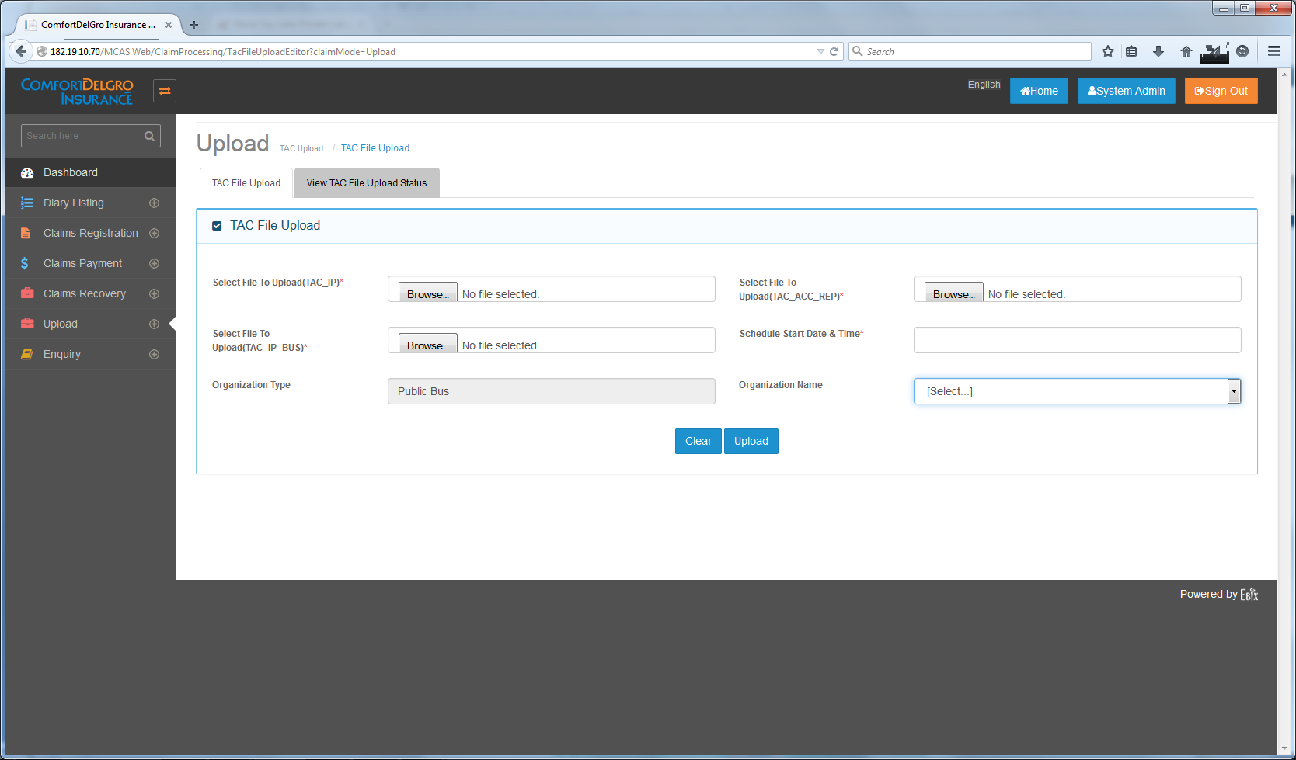

# Field Names & Functionality

1. Select File To Upload(TAC_IP)* -- Upload TAC_IP.csv File only
2. Select File To Upload(TAC_ACC_REP)* -- Upload TAC_ACC_REP.csv File only
3. Select File To Upload(TAC_IP_BUS)* -- Upload TAC_IP_BUS.csv File only
4. Schedule Start Date & Time* -- To set Date & Time to process these files. If this is set, these files will be uploaded to a particular folder (to be created) in the Server for processing at the required Date and Time.
5. Clicking on the Upload Button will automatically generate a Upload Reference Number.
6. Organization Type to default to Public Bus (will check with CDGI on Train)
7. Organization Name will reflect those Organizations created with Organization (Business Unit) Category as Bus.

# TAC File Upload Status

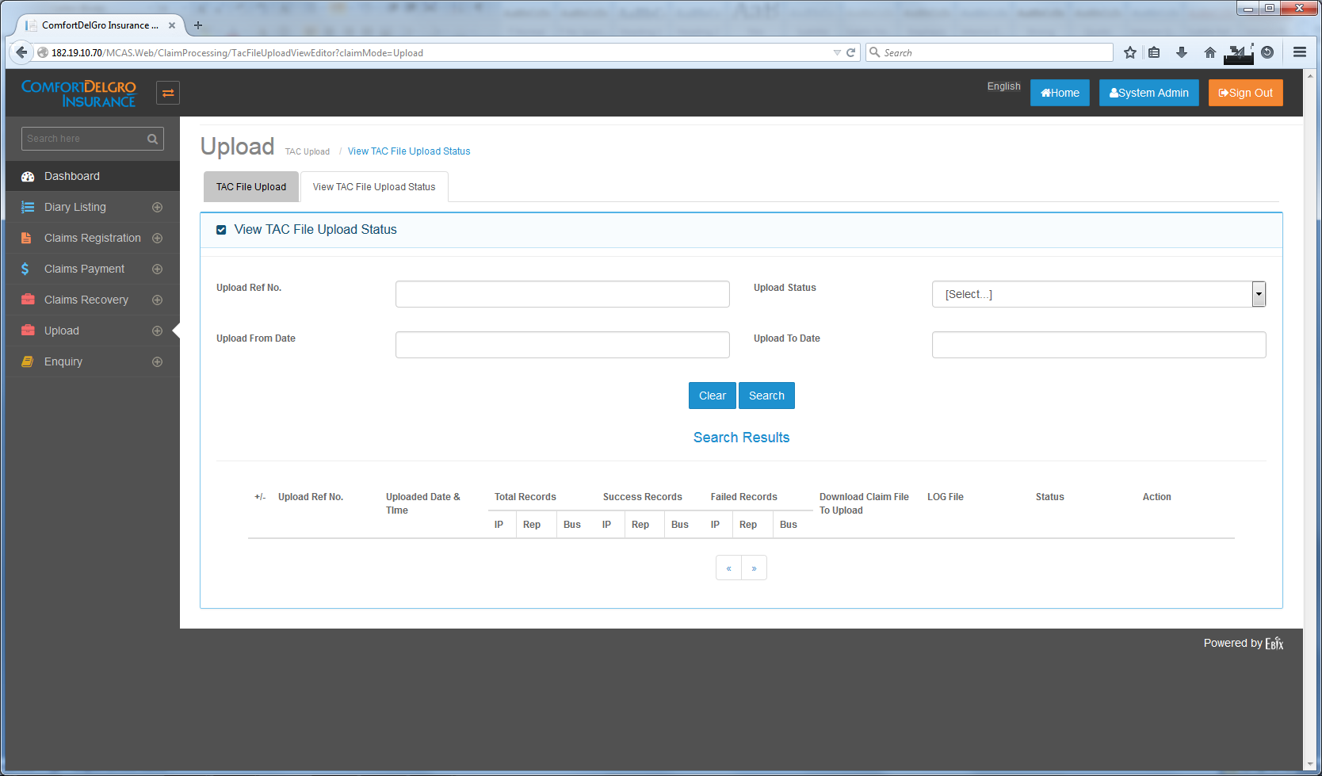

# Functionality

1. This Screen will display the Results of the TAC File Upload.
2. User can search for particular Upload Reference Number
3. If all records have been converted successfully – A TAC Claim File can be downloaded (Note that if there are any failed records, this file will not be allowed to download)
4. If there are any Failed Records, a LOG File will be generated to tell users – which File has the failed record and what is the error.
5. A ReUpload Link will appear on Action Column.
6. This ReUpload Link will re-direct User to the TAC File Upload Screen Layout and user to reupload all the files again.
7. System is to show all the episodes of the Upload and ReUpload done for a particular Upload Reference Number.
8. Denote the Episode by “-1” to the end of the Upload Reference Number for the first reupload and “-2” for the second reupload.

# The Re-Upload Screen Layout



**To Include:**

* The Upload Reference Number (to be created) on top of the Select File to Upload (TAC_IP) Field.
* The Organization Type & Organization Name will be blocked for editing
* Schedule Start Date & Time will still work.

# Claim Upload Screen Layout

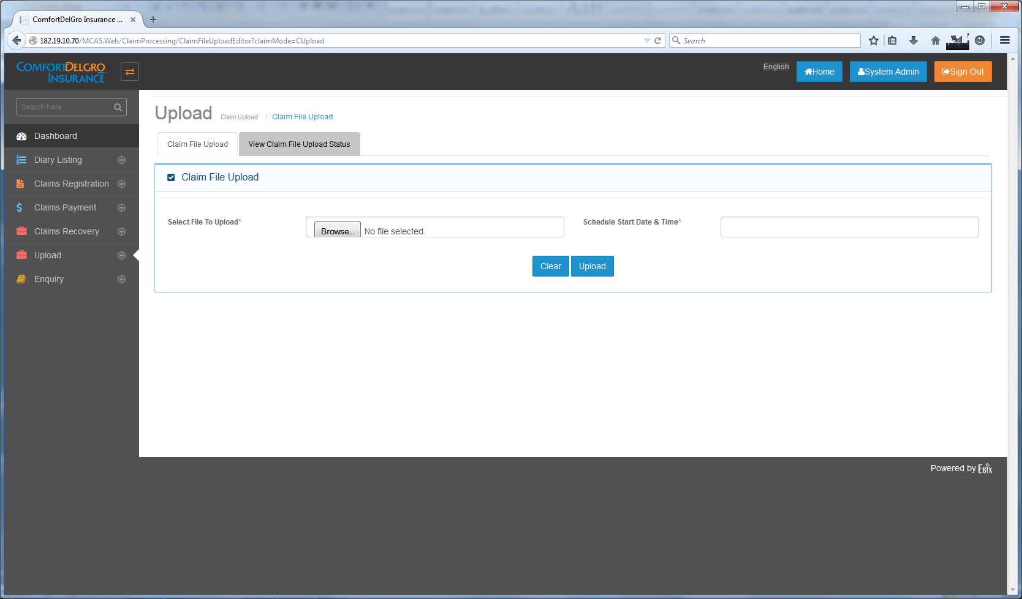

**New Fields To Include:**

* Organization Type (Compulsory) – Display all the Business Units (Public Bus, Train, Private Car, Private Bus, Rental Vehicle, Commercial Vehicle, Taxi)
* Organization Name (Compulsory) – Display Organization according to selected Organization Type.
* A “Select File To Upload(TAC_Standard_Code)*” Compulsory Field if Organization Type is Public Bus (or Train – to be confirmed by CDGI).
* Change Select File To Upload Field to Select File To Upload (SAP) if other Organization is selected (other than Public Bus & Train)

# TAC Claim Upload Process:

* User needs to upload both TAC Standard Code File and the downloaded Claim File converted from the TAC File Upload Section.
* Both files are compulsory.
* User can schedule date and time.

# SAP Claim File Upload Process:

* User needs to upload one SAP CSV File
* This file is compulsory.
* User can schedule Date and Time.

# Claim File Upload Result (for both TAC & SAP)



Note: current Screen Layout needs to be replaced with a similar screen layout like the one from TAC File Upload Status.

**For TAC:**

* System needs to display successful and failed records for both Standard Codes and Claim File.
* System needs to provide ReUpload Link (screen is similar to TAC ReUpload Link) for both Standard Codes and Claim File.
* System needs to process both files successfully before populating the fields to the Application and generating a Unique Claim Number

**For SAP:**

* System needs to display successful and failed records for SAP File.
* System needs to provide ReUpload Link (screen is similar to TAC ReUpload Link) for SAP File.
* System needs to process the file successfully before populating the fields to the Application and generating a Unique Claim Number

# Fields Mapping

|  |  |  |  |
| --- | --- | --- | --- |
| **S/N** | **File Name: TAC_ACC_REP (First File)** |  | **System Field Name** |
| 1 | Column A: Report No. | > | Main Identifier to Match TAC_IP |
| 2 | Column D: Report Date | > | Accident Details > Reported Dates |
| 3 | Column E: IP Number | > | Accident Details > IP No. |
| 4 | Column F: Date of Accident / Time (Have to spilt the field into two) | > | Accident Details > Accident Date & Accident Time (Note that the time is 24-HR Format) |
| 5 | Column H: Place of Accident | > | Accident Details > Accident Location |
| 6 | Column N: Operating Hours (code to convert from Standard Codes) | > | Initial Findings > Operating Hours |
| 7 | Column AD: Investigation Officer (code to convert from Standard Codes) | > | Initial Findings > Duty IO |
| 8 | Column AF: Damage To Bus | > | Accident Details > Damages |
|  | Column AG: Facts of Incident | > | Accident Details > Insured’s Report |

|  |  |  |  |
| --- | --- | --- | --- |
| **S/N** | **File Name: TAC_IP (Third File)** |  | **System Field Name** |
| 1 | Column A: IP Number (to match TAC_ACC_REP) | > | Accident Details > IP No. |
| 2 | Column D: Date of Accident / Time (Have to spilt the field into two) (to match TAC_ACC_REP) | > | Accident Details > Accident Date & Accident Time (Note that the time is 24-HR Format) |
| 3 | Column J: Final Liability Date | > | Initial Findings > Date of Final Finding |
| 4 | Column K: Final Finding | > | Initial Findings > IO’s Final Finding |
| 5 | Column O: Place of Accident (to match TAC_ACC_REP) | > | Accident Details > Accident Location |
| 6 | Column U: Operating Hours (code to convert from Standard Codes) | > | Initial Findings > Operating Hours |
|  | Column AO: Investigation Officer (code to convert from Standard Codes) | > | Initial Findings > Duty IO |
| 7 | Column AP: Damage To Bus (to match TAC_ACC_REP) | > | Accident Details > Damages |
| 8 | Column AQ: Facts of Incident (to match TAC_ACC_REP) | > | Accident Details > Insured’s Report |
| 9 | Column AU: Report No | > | Not in use. Use this as Main Identifier between TAC_IP & TAC_ACC_REP |

|  |  |  |  |
| --- | --- | --- | --- |
| **S/N** | **File Name: TAC_IP_Bus (Second File)** |  | **System Field Name** |
| 1 | Column A: Report No |  | Not in use. Use this as Main Identifier between TAC_IP & TAC_ACC_REP |
| 1 | Column B: IP Number (Main Identifier to match TAC_ACC_REP & TAC_IP) | > | Accident Details > IP No. |
| 2 | Column D: Bus Number | > | Accident Details > Vehicle No |
| 3 | Column E: Service No | > | Accident Details > Bus Service No |
| 4 | Column L: Final Liability | > | Initial Findings > Final Liability |
| 5 | ~~Column L: BOI Results (Not in used)~~ | ~~>~~ | ~~Initial Findings > BOI Results~~ |
| 6 | Column U: Staff No | > | Driver > Bus Captain Code (System is to match this Code with the Bus Captain Master Table to populate Name, NRIC & Mobile No.) |

Note: Fields populated by TAC File Upload and SAP File Upload will not be allowed for editing.

# Field Mapping Process

The File Processing Process will be in the order:

TAC_ACC_REP > TAC_IP_BUS > TAC_IP

During the Field Mapping Process, Validation is to include:

* Values in the field are the same – proceed to process
* Values are different – do not process and highlight in the LOG file which field(s) is the one with issue.

(Any other Validation, India Team please suggest and implement)

# Field Mapping Output

Claim File Output:

|  |  |  |  |  |  |  |  |  |  |  |  |  |  |  |
| --- | --- | --- | --- | --- | --- | --- | --- | --- | --- | --- | --- | --- | --- | --- |
| **Report No** | **Report Date** | **IP Number** | **Date of Accident/Time** | **Place of Accident** | **Operating Hours** | **Investigation Officer** | **Damage to Bus** | **Facts of Incident** | **Bus Number** | **Service No** | **Final Liability** | **Staff No** | **Final liability Date** | **Final Finding** |

# 17.1 Example Of Field Mapping Output

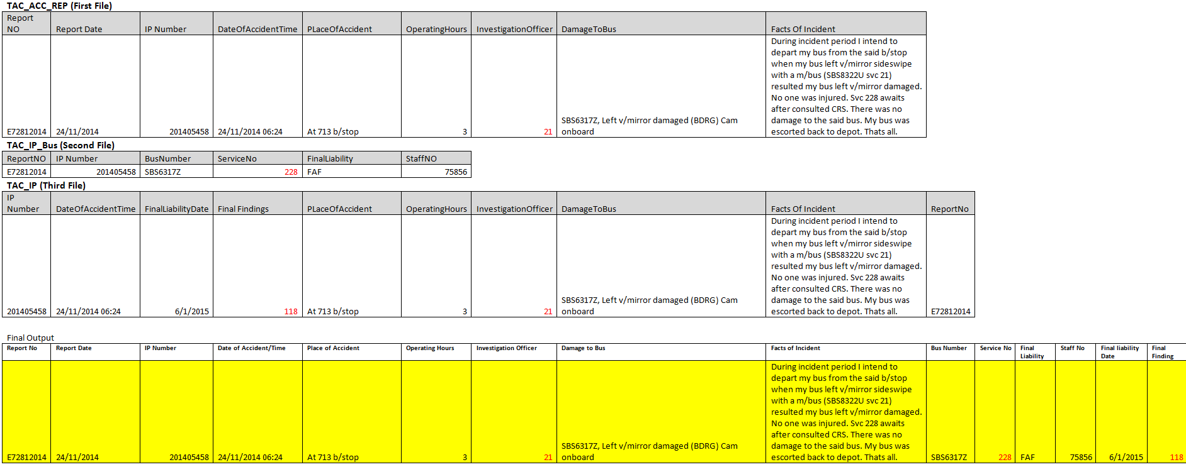

Note: Report Number is not to be mapped into system.

# 17.2 Field Mapping Validation

* Report No. is unique throughout.
* Final Liability (from TAC_IP_Bus), Final Liability Date (from TAC_IP), Final Finding (from TAC_IP) Fields are not compulsory fields so these fields can be mapped even when they are empty. The rest of the fields are compulsory.

# Updating Of Claims

There will be times that there are new details being overwritten by TAC Team on existing claims therefore CDGI needs to upload these details into the System.

Requirements / Validation:

* During Claim File Upload, System needs to detect if similar entry has been uploaded
* System can use Report No., IP No. and/or Vehicle Number to detect for similar entry.
* If yes, field values from the new file upload will overwrite the existing values in the Accident Screen.
* Manual Inputs from User in the Accident Screen as well as other screens will not be overwritten.
* System needs to either email users that there’s change in the Claim Entry or to highlight in the screen with a prompt. (India Team to suggest which is the better option).

# Rule

|  |  |  |  |  |
| --- | --- | --- | --- | --- |
| **IF** | **Then** | **Else** | **And** | **Or** |
|  |  |  |  |  |
|  |  |  |  |  |

# Implementation

## Current Implementation

* File Upload does not exist in application

## Targeted Implementation

* File Upload Creation

# Change Required

# Clarification Required

[India ebix 13 February 2015]

1. If files upload got failed, we will generate log file that can be downloaded. User will see the log and click on re-upload link to re upload file. Please confirm our under standing
2. Claim Upload status needs to be redesigned and we cannot have same columns of claim upload status as per TAC upload. TAC upload will show three files result and Claim upload will show two files status.
   1. Can we make changes in UI of Claim upload status file for two files?
      1. Screen will show claim and standard codes file as column heading.